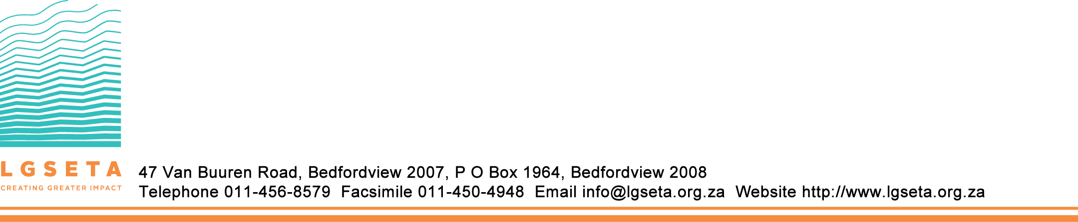

Learner Enrollment Form
Learner Name:
Learning Programme
Project Refernce
Financial period
Learner Working Status
Highest Grade Completed (e.g. Grade 10, 11, 12)
Title of Highest Qualification
Project Commencement Date
Project Termination Date
Additional Amount

Section A: Learner Details
First Name
Last Name
ID Number
Date of Birth
Equity
Nationality
Disabilty
Gender
Citizen Status
Physical Address
Postal Address
Province
Municipality
Residential Are
Contact Cell
Contact Phone
Contact Fax
Email Address

Parent or Guardian Details
(To be completed if learner is a minor - i.e under 18 years)
First Name
Last Name
National ID
Physical Address
Postal Address
Contact Number
Email Address

Lead Entity
Name of Entity | City of Johannesburg
Skills Development Levy Number (SDL) | 030719944
Registration Number | N/A
Sic Code | 91300
SETA you Aligned to | LGSETA
Physical Address | Thuso House
Designated Persons Name and Surname | Sambo Hlamarisa
Designation | Skills Development Facilitator
Tel Number | 0635033522
Fax Number | N/A
Email Address | Hlamarisas@joburg.org.za
Fax Number | N/A
Signature | 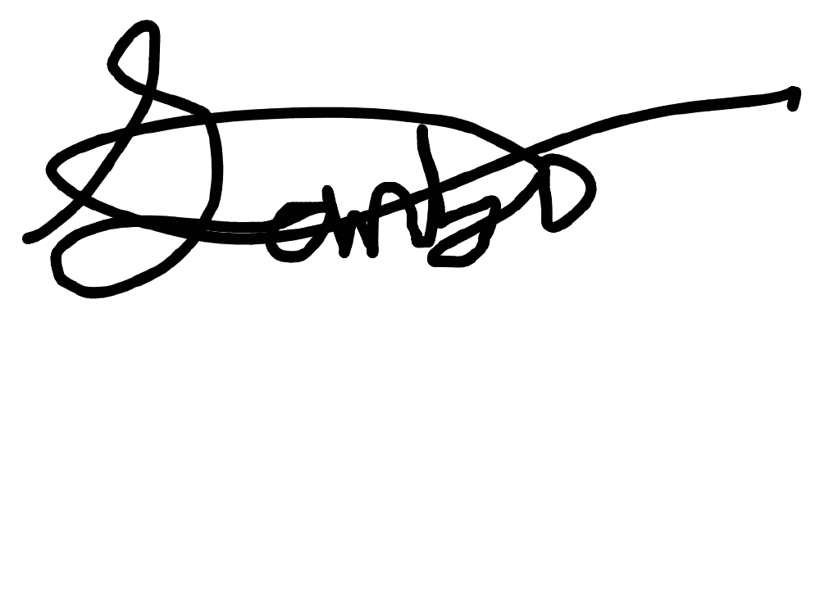
Date | 16/01/2026

Host Employer
Name of Entity | City of Johannesburg
Skills Development Levy Number (SDL) | 030719944
Registration Number | N/A
Sic Code | 91300
SETA you Aligned to | LGSETA
Physical Address | Thuso House
Designated Persons Name and Surname | Sambo Hlamarisa
Designation | Skills Development Facilitator
Tel Number | 0635033522
Fax Number | N/A
Email Address | Hlamarisas@joburg.org.za
Fax Number | N/A
Signature
Date | 16/01/2026

Skills Development Provider/Institution Qualification Attained
Name of Institution | GROWTH MANAGEMENT CONSULTING
Accreditaion Number | LGRS-1076-130819
Registration Number | 2020/594338/07
Qualification Name | 119332
NQF Level | 5
Provider Type | PRIVATE
Provider Class | N/A
Physical Address | 526 CONSTANTIA SQUARE, 16TH ROAD, MIDRAND, 1685

Designated Persons Name and Surname | RUTH MPOFU
Designation | DIRECTOR
Tel Number | 0820522173
Fax Number | 0862437811
Email Address | ruth@growthmc.co.za
Signature | 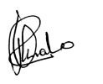
Date

Unit Standard Details
Unit Standard Number | Unit Standard Title | Credits
119332 | Manage and develop oneself in the public sector work environment | 10

Learner Declaration
(Please note that the Guardian Signature is required if the learner in under 18 Years)
1. I Declare to The Best of My Knowledge That All Information On this Form is True and Correct. I Understand That If it is Not and Any Falsehoods or Omissions are Discovered my Grant May Be Terminated
2. I Undertake to Avail Myself for Participation in All Structured Learning, Practical Workplace Experience and Assessment Activities Required by the Programme
3. I Indemnify The LGSETA and its Officials Against Any Claim for illness or Acidental injury Sustained by Me in During this Programme
Name and Surname of Learner
Signature of Learner
Name and Surname of Parent or Guardian
Parent or Guardians signature

